**GOVERNMENT SURVEILLANCE, TECHNOCRATIC OPPRESSION, AND BIG TECH CENSORSHIP**

CHARLES BISHOP JR.

SOC 205: SOCIAL PROBLEMS

BRIAN WITTRUP

MAY 16, 2022

**Abstract**

I authored this paper and became interested in the idea and concept of government surveillance, technocratic oppression, and big tech censorship because I have always been fascinated by the concepts of technology and authoritarian government regime. I started seeing a trend in the early 2000’s regarding technocratic capability in the governmental powers in the United States of America and this paper is a culmination and a precipice of a tipping point in terms of the transition in the abstraction from theoretical knowledge into documented fact. I became fascinated with technology after 9/11 and the TSA started rolling out the imaging body scanners/sensors in the airports that could see through citizens clothing. The question this research seeks to answer in this paper is why government surveillance, technocratic oppression, and big tech censorship is utilized in a society and what aims, means, and goals government surveillance, technocratic oppression, and big tech censorship aim to accomplish in the 21st century. I expect to find at the end of this paper a solution to how to combat the problem of government surveillance, technocratic oppression, and big tech censorship through a call to action or a collective action that can be undertaken to combat the technocratic regime and technocracy. I will be using theoretical technological methodologies and factual technology capability to explain the mechanisms and constructs of government surveillance, technocratic oppression, and big tech censorship.

*Keywords:* technocratic oppression, government surveillance, agenda 2030, agenda 21, graphene oxide, panopticon, ID2020, quantum microdot vaccine delivery system, Bill Gates, LUCIFERASE, nanotechnology, DARPA, Neuralink, Starlink, Ai sentient world simulation, technocracy, vaccine, one world government, new world order

Sociological issues and sociological problems have permeated the social strata and human realm with the confined of the decadent human experience for eons. Human beings have an innate disposition and natural tendency to create problems and a conflux of an orient to create conflict in their daily interactions, functioning, and happenings in society and in the daily life realm of experience. The spectrum and ranges of these social problems and social issues extend through the chasm of human-to-human interaction and bond into the institution-and-human experience, relationship, and macrocosmic human-and-nature reciprocal experience and bond or relationship. Humans tend to create problems with other humans that become a transfixed reflection in society, create social problems in terms of institutions and governments that act as a mirror throughout the society, and humans also enter conflict with nature and innate human nature that create the experience of sociological issues, problems, and conflict in the social stratum experience. The range and spectrum of these sociological experience of problem extend from global warming to workers union rights to economic calamity all the way across the board to the “-ism” problems that encapsulate racism, ageism, sexism, and hedonism.

The term “sociology” was first coined in the early 19th century in the 1830s when a man by the name of Auguste Compte proposed for a creation of a “synthetic” science that would unite all knowledge and experience about human nature, activity, and role. Societal forces shape differential human experience. If I cannot understand the world around me in terms of the social interactions between human beings, I am going to be less likely to not only not understand myself, but I am going to be hindered by and create internal and external conflict because of my lack of understanding of the social processes and exchange of meaning and bond experience that is happening around me in a ubiquitous manner. Sociologists study the interaction between two people on a microcosmic level to the study of the interaction between nations and transnational corporations on a macrocosmic level. I am going to bring light to a sociological problem and sociological issue that will bridge the gap between the three realms of human-to-human experience, human-to-institution experience, and human-to-nature experience. The sociological problem I am going to bring light to and shed attention upon is the sociological experience and sociological idea and proliferation of “Government Surveillance, Technocratic Oppression, and Big Tech Censorship.”

The idea of a “social problem” is defined on page two of the textbook, “Social Problems: Continuity and Change” as, “any condition or behavior that has negative consequences for large numbers of people and that is generally recognized as a condition or behavior that needs to be addressed.” The negative consequences of government surveillance, technocratic oppression, and big tech censorship are vast and expand through every aspect and sector of society. The negative effects of a totalitarian technocratic government include but are not limited to the forceful removal of amended ratified rights such as the freedom of speech, the freedom of the press, and the freedom of religion to the elimination of privacy included but not constricted to personal privacy but also private property rights and the dwarfism of the pathology of the collective sociological thought process into an artificial algorithmic group think pattern that punishes anomalous thinking and rewards assimilation and conformity to the group think and group thought sociological process.

The nostrum of this technocratic agenda and technocratic movement is to streamline and artificially assimilate and enhance through digitization and replication of all human experience and human emotion into one conduit and strata of a dystopic confabulation and assimilated proctor to the human emotionless state of anhedonia usurped into an augmented emotional and psychological control stratosphere and sociological human perception and experience. If I can introduce a complex problem into the sociological atmosphere or society that creates a mass panic and hysteria and creates a fear-based complex extensive elaborate reaction I can then use the fear generated from this problem-reaction to create a problem-reaction-solution that fits the perceived technocratic agenda that I seek to deem to attach “fit” for the surrounding society. For example, if I use COVID-19 as the complication as is in the current health crisis in American society, I can use this problem and complex concept of a “pandemic” and a healthcare crisis to usher in a totalitarian technocratic regime under a guise of healthcare and health treatment new world order.

The three sociological theoretical perspectives that I have learned in this class are conflict theory, symbolic interactionism, and functionalism or structural functionalism. Conflict theory is summed up on page twelve of the textbook, “social problems arise from fundamental faults in the structure of a society, and both reflect and reinforce inequalities based on social class, race, gender, and other dimensions.” Functionalism is described as, “social problems weaken a society’s stability but do not reflect fundamental faults in how the society is structured” and view social problems as important functional conduits in the society despite their negative effects. Symbolic interactionism is described on page twelve of the textbook as, “social problems arise from the interaction of individuals. People who engage in socially problematic behavior often learn the behavior from other people.” I.e., people replicate and mirror behavior that is practiced in the surrounding environment in terms of human sociological experience. In terms of the social problem of “Government Surveillance, Technocratic Oppression, and Big Tech Censorship.” The three sociological perspectives can be applied in a plethora of ways to government surveillance, technocratic oppression, and big tech censorship.

Government surveillance, technocratic oppression, and big tech censorship are loaded concepts. The three conceptual undertakings and understandings on their own as separate sociological structural issues and problems entice and invite sensationalism and uncomfortable feeling and emotion and when all three are morphed into one conduit of a unified concept and idea the immediate reaction may be a sensation of unabated cognitive dissonance. Nevertheless, this is a sociological problem and sociological issue that needs to be brought to light and have credence heeded to before the problem escalates to a point of “no return” so to speak. The concept of government surveillance can be argued to be traced back to the inception and the ratification of the Bill of Rights when the Fourth Amendment went into effect on December 16, 1791.

The fact that the United States of America persisted for fifteen years prior to the inception of this amendment and deemed it necessary after fifteen years to create this amendment alludes to the fact that the government may or may not have been conducting illegal search and seizure of properties prior to 1791 from 1776-1791 otherwise the founding fathers would have not seen a requirement to include this amendment in our rights or points to the notion that prior to the inception of the United States of America the colonists may have been experiencing the act of “illegal” search and seizure of their homes and properties by the British monarchy. Nevertheless, this amendment was ratified in 1791. In 1952, President Harry S. Truman established the National Security Agency or the NSA.

The NSA was created in 1952 and sown and seeded out of the understanding that the importance and distinct and overt character of communications intelligence justified an organization distinct from the armed forces and the other intelligence agencies. In other words, the NSA was manufactured and conceptualized to provide an effective, unified ubiquitous omnipresent organizational front to control the communications intelligence activities of the United States conducted against foreign governments and foreign adversary. The fact that the United States deemed it necessary to create an intelligence conduit and chasm outside of the bounds and realm of the military whose specific and sole job was to monitor and intercept communication against and from foreign government is understandable and reasonable what is not understandable although is how this NSA agency used the centralized circumvented power against the people in its own society and government in the United States of America. The first evidence and factualized conjecture of proof of this came to appearance on the surface in 2013 when the National Security Agency contractor Edward Snowden blew the whistle on a mass surveillance program of Americans’ telephone records being conducted by the NSA and that this “warrantless telephone consortium” secretly collected millions of Americans’ telephone records and violated the Foreign Intelligence Surveillance Act by acting on our own soil, their own recognizance, and against our own free will as human beings.

I am not certain as to the governing laws and governing body that surrounds and encapsulates the monitoring of data in terms of the United States of America by its own government through the NSA on its own citizens, but I do know for a 100% fact that the CIA is not permitted to conduct operations on American soil and factually violates this ratified enacted law agreement on an almost daily occurrence. In terms of functionalism theory, the fact that the government and governing body goes to extreme overt measures to monitor and surveille the population suggests the fact that the institution of the United States government perceives the government surveillance as a conduit to create “social stabilization” through the monitoring of a potential threat and a potential threatening activity in the society to avoid problems such as terrorism and circumvent violence prior to the inception of a violent activity.

The undertaking and concept of government surveillance in this notion is conceptualized as the percept of the institution of the centralized government performing the important function of monitoring and conducting data surveillance to help promulgate the safety of not only the physical bodies of the members in the society but also to uphold the social fabric, hiatus, and construct of the authoritarian sub struct throughout the annals of the social structure and social stratum to not only assign a functionalist meaning and definition to the existence and function of the government but for the citizenry membership pool to embody and to perform the function as being members of a society and social functionalist system that gives definition and assigned meaning to the members of the social stratosphere through “importance” in society by invoking the feeling of the need to have to be monitored and surveilled in terms of daily conduct and day-to-day activity.

. In other words, the societal symbolism and meaning of a government that is conducting a surveillance program manifests a function of inherent quantifiable value in the meaning people attach to themselves and their government via being under a surveillance program through a societal “care” and societal “safety.” protocol and relational experience. It is the same concept as when my mother and father use to ground me as a child and take away my PlayStation while it served the formidable social function of lambasted punishment on one hand, I derived meaning through the assignment identification to the negative attention and negative value correlated to the direct action that I committed in the social household and world at that time in retrospect. The government serves the function of being a “governing” body conduit through a surveillance program that it rationalizes as “governance” that indirectly contributes to the members of the social stratum as being part of, undertaking, and contributing to the embodiment of a citizen and a member of a social role under a governing body system that has derived meaning, value, and societal role norm formation to replicate.

The social manifested problematic nature of extensive government surveillance is a paradoxical sociological ideological dilemma dual meaning. On one hand, the government surveillance program erodes a society’s stability complex through a collective and unified distrust and mistrust of the government and the surrounding social atmosphere as a whole and on the other hand strengthens the instability of the society through a “safety” and “care” platform that avoids the sociological manifestation of a violence in the collective subconscious nature within the social structure. Government surveillance acts as a two-fold sociological problem-solution. The surveillance programs prevent the sociological issues of crime and violence on one hand but on the other hand the police force and government itself use the social conduit of violence to enforce policy, agenda, and laws. The problem of violence is utilized under a platform of violence to prevent violent tendency in the collective.

Despite this negative concept, the social problem of government surveillance proctors an important meaningful function in society to aid in crime prevention, social assimilation, crime tracing, and control and provides the social identification to an important social role through attention being concentrated and siphoned into a complex elaborative control contraceptive that people perceive the surveillance not only as a government that is showing “compassion” and “care” but also solidifies social roles through the conceptualization of being a recorded social member subject under the lens of a camera. If social roles were not important in society, there would be no cameras to record the activities. In terms of conflict theory, government surveillance acts as the conduit not only to be representative in terms of equality but also a representation of a small ruling “elite” class of the government that is conducting the surveillance with a subservient “serf” population being under surveillance that also aids and brings credence to the fact that the surveillance programs are aiming to create an “egalitarian” society where all citizens are equal under the watchful eye of the surveillance system based upon conflict theoretical perspective.

Everybody and everyone are equally surveilled in the technocratic dystopic egalitarian society. Lastly, in terms of symbolic interactionism the symbol of the government surveillance not only conveys importance in the eyes of the social roles but the camera recording also acts as a symbol that is replicated to reach a shared understanding of interacting with the external world that is also deemed important enough to be recorded outside of the human societal role and human experience as social member role states. The symbol in terms of government surveillance is the camera, the surveillance power, and the surveillance control. Government surveillance ushers problems into social fabric in terms of symbolic interactionism under the guise of social member states replicating the monitoring of each other not only to create a panopticon of a state of sensationalist fear, but as is evidenced right now in the present in the current society members will record problematic social behavior that is being performed such as violence and rape that is taking place in the surrounding environment and society versus trying to stop the violence or calling the authorities and preventing the activity of the social problem manifestation. This is evidenced by the recent rape that took place on the train system in Philadelphia where citizens recorded the rape for hours before anyone called the police or did anything about the interaction to try to stop the rape from happening and being conducted.

Technocratic oppression is characterized as centralized “government oppression” through a system of laws and a body of governance and control under a social system of technocratic origin. A technocracy is a form of government in which the decision-maker or makers are selected based on their expertise in each area of responsibility, particularly about scientific or technical knowledge. The notion of a technocracy and technocratic government is a new concept and bridges the gap and connects the concept of the previously addressed “government surveillance” to the concept of “technological monitoring” systems in the construct of the surrounding society and social environment. Scientific and technological science and concept is applied to power structures and system(s) of governance and business. In terms of the dissertation and paper that I am extrapolating today, medical science and technology are merged and morphed into one morphism to represent and signify oppression through dualistic and parallel medical scientific-technological mechanism.

Technocratic oppression can be seen on a macrocosmic scale in social structure in recent times in terms of a few concepts and dynamics that I will introduce in this paper but will not be the main articulation points of discussion. The concepts of the different theoretical perspectives of how Russia manipulated the 2016 Presidential election by mass disseminating through Facebook algorithms via stories and data about Hilary Clinton that was unfavorable towards Hilary Clinton that swayed the election in Donald Trump’s favor is a prime example one way technology can be used to oppress one faction of a society and promote another faction in terms of the dichotomy of republican versus democratic presidential election. Another current example of technocratic manipulation is the concept of how theoretical “technologists” postulated the idea that the recent 2020 election was re-manipulated to sway towards a democratic win via manipulation of the data constructs and technological capability and mechanism inside of the Dominion voting machine algorithm input-output data system. The theoretical technological perspective is that the mega-tech company connected to the machines had connections and links to the democratic national convention and the democratic party. I am not going to be using these examples in this paper as to a conceptual understanding of technocratic oppression, I am using these two conceptual theories to seed the idea of how technology can be used to alter and manipulate the social fabric of the surrounding environment and the social-political-cultural stratosphere.

The functionalism theoretical application to these two examples of generalized technocratic oppression extemporaneously exemplifies how volatile society became and has become because of the perceived manipulative tendencies of these two technological manipulation methods and mechanisms. The social unrest and divisive polarization extreme spectrum of the right and the left in terms of the political sphere symbolize how when technology is utilized to manipulate a political election, structural functionalism and technologically induced “strife” can be the result and mitigating response. The concept of the 2020 election being controlled and “rigged” goes deep into the rabbit hole of technological “PsyOp” or Psychological Operation programs being orchestrated on the general population and is evidenced by research studies being conducted through surveys as to how a large majority of the population believes that Donald Trump is still President of the United States and that an Ai supercomputer technological system created the “Q” conspiratorial movement to manipulate and alter the fabric of the social reality and social conscience in terms of the collective social singularity perception system.

In terms of structural functionalism, technocratic oppressive tendency serves the role of manufacturing an identity complex and social “ID” for people to adopt and embody in the social role system and social role hierarchy. Preceding the advancement of technology, if people were to develop theories like this that are “conspiratorial” the people would be met with disdain and no identity could be formulated and created. In terms of today, the advancement of technological means to the point that it has accomplished allows for the extensive embodiment of lavish and semi outlandish theories to take hold and attach to people's identification concept in their social roles through far-reaching theories and technology has made these theories a potential social plausible notion and undertaking.

Technocratic oppression heeds credence to giving people an identity or “ID” in the social system under a definition of a sensation of importance in terms of a group of people and a body of social members being “monitored” and surveilled by a technocratic mechanistic technological system. The purpose of these technocratic oppressions takes many forms, and the two generalized election examples are a perveance of how simple technological manipulation theory can provide collective perceived meaning and alter reality and sociological identity through the function of different reality “bubbles” to adapt and conceive to perceive. The technocratic despotism or tyrannical autocratic systemic nature in the functionalist form in these two pervasive examples is technological manipulation of data to sway an election; ensuring the societal authoritarian construct of the controlling political party that can manipulate elections and subvert formation of overt conscious opinion through covert technological capacity and ensure the stability of a systemic structure and form of a technocratic government through technological jurisdiction that is replicated socially through adaptation of identity constructs in the social fabric of the reality in the “techno-verse” societal system.

Conflict theory via technocratic oppression manifests in construct through the manipulation of public generalized opinion and collective sociological perception to adhere to an “equal” build through technological systems that provide conceptual political identities, govern the inherent thought process and communication platforms through “safe zones” and Facebook monitoring and fact checking organizations, such as Reuters, and cybernetic surveillance systems that ascertain and guarantee that people think and perceive the world in a methodical way that is socially “acceptable” and desirable. The technological monitoring cybernetic data platforms that identify and flag specific speech pattern and pathological “trigger” words are designed to “reduce” social inequity through "-ism” prevention via technological flagging of “-ism” such as racism and sexism whilst at the same time these technological nepotistic Orwellian dystopic systemic platforms discourage and eliminate the advent of free speech.

The fundamental “faults” that are annotated and flagged as controversial in the social system whether it be via racist, sexist, or violent ideology are organized into one data monitoring conduit that is used to create “far-reaching” alteration in the structure of the social stratosphere. This is evidenced right now by how Elon Musk is attempting to acquire through fiscal means the platform of Twitter and how the big tech companies that have been participating in technocratic oppression are upset and disheartened and are trying to prevent the centralization of power within the Twitter platform to be under a control of a person that is a proponent of free speech and constitutes the opposing viewpoint of their own political identity and viewpoint. The other interesting concept is how the big tech companies are dispirited by the fact that Musk is trying to remove “verified” users from the platform and make everyone equal in terms of their social “verified” status. This exemplifies and mirrors the concept of an elite subsect of the population holding superior ethnocentric identity in terms of the social value roleplay system. Otherwise, the big tech executives would not care about whether people held “verification” status or not in terms of the social value of the member of the social construct and social constructed systemic nature.

The technocratic oppression symbolizes in terms of symbolic interactionism as a “thought monitoring” conduit to streamline thoughts through the collective panopticon and the generalized social system into modalities of methodological thought pathology that serves the desired technocratic agenda and technocratic control aspiration of the Technosphere of the nepotistic elite. The technological platform and the technological oppression acts as a symbol of overt control and covert power and the shared symbolic interaction of having the processes of the words and thoughts of the masses monitored, censored, and manipulated through big technocratic platform(s) create a societal institution where people are hypersensitive as to the thoughts and the words that are broadcasted to the masses and on an individual level between the interaction and exchange of semantic, verbal, and nonverbal cues and symbols in the symbolic interactional exchange of reciprocated assigned meaning. The symbol is control and power, and the shared symbolic interaction is not only the possession of control and power but the vying for control and power while being under a system of overt and covert control and power mechanisms and shared meaning and experience.

The problematic issues that are arising out of the influx of these continuously evolving technological platforms are extensive and profound. Now that I have conjectured and explained the three different sociological perspectives as applied to the conceptual understanding of the notion of “Government Surveillance, Technocratic Oppression, and Big Tech Censorship” and have provided factual examples in real life in the current society about how technocratic mechanistic action has been orchestrated and used to manipulate and alter the functionalist, conflict theorist, and symbolic interactionist theory of “Government Surveillance, Technocratic Oppression, and Big Tech Censorship” I am going to conceptualize and dissect and use this established generalized platform-concept to apply to a subsect of the Government Surveillance, Technocratic Oppression, and Big Tech Censorship control platform to orchestrate a painted picture of a potential future neo-Orwellian egalitarian dystopic social erect construct that is being proliferated, orchestrated, and assimilated under the guise of a healthcare crisis response and respondent forced participation system. I am going to gauge the various epistemological causes and explanation-based origins that have been linked to this technocratic system and siphon through the sociological data and sociological factors that contribute to the proliferation of this future problem-nation technocratic autocratic tyrannical nation-state. Lastly, I am going to shed light upon how sociologists and other experts formulate potential solutions to this authoritarian social problematic control structure, the response recommendation, and the method to solve the problem.

In regard to “Government Surveillance, Technocratic Oppression, and Big Tech Censorship,” I am going to disseminate how the government surveillance, technocratic agenda, and big tech censorship platform and regime that is being rolled out now and is going to be rolled out soon connected to the COVID-19 health crisis pandemic and extrapolate upon the various technological mechanisms and technological device platforms that will be used to accomplish the establishment of a one-world technocratic governmental control system and social regime. The COVID-19 pandemic began on the day of December 12, 2019, when a cluster of patients in Wuhan, China began to experience the symptomology of shortness of breath and a fever.

A large 5G rollout was completed in Wuhan while the Coronavirus manifested itself in Wuhan, China. I am not going to go too in depth with “conspiratorial” theorized notion in this paper, but I am going to begin this section of the paper by ascribing the fact that radiation sickness from 5G millimeter waves, the SARS-2-COV coronavirus, and graphene oxide toxicity and graphene oxide poisoning have the exact identical and parallel symptomology omnipresent and omnipotent across the board in terms of the symptomology of fever, chills, cough, shortness of breath, difficulty breathing, fatigue, muscle aches, headache, loss of taste or smell, sore throat, congestion, nausea, vomiting, and diarrhea. I am starting out this paper with this connection not to be conspiratorial but to heed credence upon the notion that technology can be connected to medical science and this medical science can be connected to technocratic control. I am going to focus on the specific technological theory and application connected to the disease and stay away from the medical and health discrepancies in factual leaps of logic that defy rationale and reasoning such as the fact that the diffuse pattern is parallel and identically symmetrical in “COVID-19” that is indicative of graphene oxide poisoning/5G and not a natural zoonotic disease. Natural diseases do not create perfect symmetrical diffuse pattern. The exact MM wavelength to affect the human body and cause damage is 60MM wavelengths, the exact wavelength of the 5G EMF RF MM wave function system.

In “technocratic belief or civil society: reflections on typological concepts of sociology” (Shcherbina, 2019), A.V. Shcherbina states, “typological concepts constructed by sociologists and a built-in hierarchy of problem significance provide social change interpretation schemes and turn into social representations. Spreading a technocratic belief in a collective consciousness indicates the loss of heuristic potential concepts by a post-industrial, information society.” (Shcherbina, 2019) and further states, “Technocracy has ceased to be the property of a certain social stratum, it is imputed mass consciousness, and affects the entire landscape of social representation.” (Shcherbina, 2019) I.e. Shcherbina brings light to how the interpretation of problems can be “built-in” to a sociological system through problem significance identification therefore the problem significance identification will provide social change “platforms” that encapsulate and manifest “social change” interpretation schematics.

In the case of the COVID-19 pandemic, the built-in hierarchical sociological problem(s) is the built-in health dilemma and dangerous health catastrophe that then can be used to enact and enforce a social change schematic and manufactured deliberate strata through interpretation of the sociological problem-reaction-solution complex. The “pandemic” acts as the conduit and power vacuum to enforce social manipulation through public health crisis interpretation and the concept of “heuristic” loss that A.V. Shcherbina points out suggests that due to a technocracy and technocratic systemic control state, people will be limited in terms of knowledge expansion and the capability to learn new conceptual understanding on their own based upon their own cognitive devices and A.V. Shcherbina alludes to how a technocratic society is not the doing or happenstance of one actor in the symbolic interactionism process it is a group of actor(s) setting in motion a collective mass sociological panopticon consciousness assimilation to a technocratic control and technocratic systemic ideological prowess and technological transhumanistic process.

To correlate the action of how a machine performs and operates to the concept of how a human functions and operates, I am going to use a quote from Norbert Wiener’s “Cybernetics: Or Control and Communication in the Animal and the Machine” (Wiener, 1961) that ascertains, “If we have our eye on the pencil, this report may be visual, at least in part, but it is more generally kinesthetic, or, to use a term now in vogue, proprioceptive. If the proprioceptive sensations are wanting and we do not replace them by a visual or other substitute, we are unable to perform the act of picking up the pencil and find ourselves in a state of what is known as *ataxia.”* (Wiener, 1961) in other words Norbert Wiener is conscribing to how the autonomous function and automated nature of the central nervous system in a human being is akin and alike a cybernetic machine whereas if the external stimuli is not sufficient to be able to identify the perceived errors in the attempt to pick up the objective pencil, the muscle will not be able to contract to correct the error and pick up the perceived pencil. In terms of the analogy to a technocratic system of governance, if the collective mass formation consciousness is not able to detect a technocratic control systemic mechanism that surrounds itself in a form of a panopticon due to the control system(s) being embedded in the central nervous system of the human beings through technological method and transhumanistic merging with technology, people will be unable to detect the control system, control the system, or change the control system. Thus, the system will control the individual. The individual will not control the system. In this case, the system is the technocratic mechanistic control technologies that are digitized and utilized by oppressive ideological governmental regimes to alter and subjugate human consciousness to subvert power.

The automated nature of the CNS can be applied to the mechanized nature of human consciousness as it relates to the recognition of a technocratic sociological authoritarian governmental control mechanisms and symbolic power system. A.V. Shcherbina further states in “Transhumanism in Analytical Prospects of Classical and Non-Classic Sociology” (Shcherbina, 2020) that “transhumanism is a new global ideology that configures images of the social world dating back to archaic myths with representations of a synthetic theory of evolution, technoscience, and social philosophy. Transhumanism is an ideology adequate to the conditions that gave rise to it and a new type of social subject: weakening nation-states and the formation of the information contour of global society, a new communication infrastructure as a space for universal material and spiritual exchange.” (Shcherbina, 2020) which converges upon the viewpoint that knowledge and experience in terms of technocratic societies I.e., transhumanistic societies, are synthetic and not an innate natural experience of the human collective consciousness. In other words, the lack of “digitized” technology in the archaic epistemological primitive natural state of primordial hominid humans in nature eons ago leaves little room for sociological archetypes to imitate and replicate as a human species that perform a function in a recall sequence in terms of the collective CNS experience as a relation to the concept that I alluded to through the work of Norbert Wiener.

The lack of a natural recall sequence of the inherent experience with digital technological devices and information-age technology is a breeding ground for a government to exploit this technological “gap” in the evolutionary collective past consciousness and utilize this technological disconnect to subjugate and subvert a collective population in an overt and covert manner. People tend to romanticize technological capability and glorify the technological advance versus perceiving how technological advent may be utilized to influence and subvert the human mind in a negative, destructive, damaging manner. In terms of symbolic interactionism, the symbolic interaction with the technological capability and mechanistic action is perceived as humans interacting in a positive manner when the technology may be distorting reality experience and manipulating perception of people in a manner that is destructive and harmful in the society. The symbol of romanticizing the archetype of technology coupled with the symbol of power and control exertion enables people to be manipulated by the exact thing that is being glorified through technological prowess and technological neo-convention.

A.V. Shcherbina further conceptualizes this understanding in “Traditional Man in the Digital Cell” (Shcherbina, 2021) by stating, “a traditional person belongs to a distinctive culture. Scientific and technological progress is a product of the Western European cultural type. The enslavement to technology is not a cause, but a symptom of its decay due to a lack of perspective and purpose. A traditional person is a person who is changing, continuing the creation of the world, and maintaining a connection with eternity.” (Shcherbina, 2021) Despite the epistemological origin of the technological advent being brought to light as a western European cultural concept, Shcherbina alludes to how the synergistic expansion of the human being morphed with technological concept could be a recipe and cacoepy to remove tradition through an extinguishing of human culture morphed into a technological dystopic potential future timeline. Further, A.V. states not how technology is a dualistic partnership symbiotic mutually beneficial bond, but how human beings are participating amongst an enslavement and in a bondage state to a technological machine. The removal of human perspective through thought subversion and thinking confluence and the removal of purpose through automation and assimilation to technological process prowess creates an exploit in the innate natural human experiential life participation through a development of a plausible existential crisis through a society devoid of human meaning and how this exploit can be taken advantage of through and capitalized upon by a Government Surveillance, Technocratic Oppression, and Big Tech Censorship system that is exponentially expansive and a power consuming vacuum.

In “TechnoBrainBodies-in-Cultures: An Intersectional Case” (Schmitz, 2021) Sigrid Schmitz theorizes upon the concept of merging human brains with artificial intelligence by stating, “The cyborgization of brainbodies with computer hardware and software today ranges in scope from the realization of Brain–Computer Interfaces (BCIs) to visions of mind upload to silicon, the latter being targeted toward a transhuman future.” (Schmitz, 2021) and describes the beneficial aspect of how the brain of humans can be utilized to be transformed in a positive trajectory and manner with technological potential. While this sounds appealing and enticing on the surface, I do not see this as becoming a reality soon. I see it being a reality for the technocratic elite to be able to take advantage of this theory due to a power vacuum and digitized monetary financial system in terms of beneficial morphism and emergence of the nepotistic human mind, experience, and body with technology, but I do not see these technological transhumanist methodologies and capabilities being mass available and mass distributed to the collective in the sociological stratosphere.

I am trying to assign meaning to how the concept of technological-human trans-morphism is glorified En masse as a collective right now although the future may be the opposite polarization of a negative technological experience and technological overtaking. Now that I have established the theorized covid 19 connections to technological mechanism through 5G and graphene oxide toxicity radiation symptomology to interlink technology and the healthcare system and explained the various sociological theories as to a technocratic agenda and over technological authoritarianism, the future aim is to focus on the technocratic and technological mechanistic control as a reaction to the problem under the auspices and disguise of a technological based platform mass formation solution. Not the symptomology of the problem-technological auspicious connection.

I have formulated the problem-reaction-solution concept through social change interpretation schematic, the loss of heuristic potential concept through post-transhumanism industrial information societal norms, the imputed mass consciousness mass formation, and the symbolic interactionism process of a group of actor(s) setting in motion a collective mass sociological panopticon consciousness assimilation via technocratic systems, the connection to the CNS that operates akin to a machine, digitized recall sequences, the glorification of technological prowess and how this affects human consciousness, and how technology will enslave humanity to paint a picture of how technological capability and human ability is directly proportional and inversely disproportionate in terms of how the technological ability goes up, the innate natural human capability decreases as synthetic human potential proliferates and becomes omnipotent. The next sector of this paper will describe the specific methodologies, formulations, and plots to encapsulate and subjugate human society and human consciousness into a panopticon dystopic cube. I will be extrapolating upon the technological mechanisms, devices, and control systems that will be utilized by a governmental megalomaniacal “elite” to create a “new” order or “new: society whose backbone and building block is Government Surveillance, Technocratic Oppression, and Big Tech Censorship.

The next document that I am going to expound upon is called, “COVID-19: The Great Reset” (Schwab, 2020; Malleret 2020) by Schwab, Klaus, and Thierry Malleret that is available on the website of the World Economic Forum. The first part of the document explains all the traditional societal implications of a pandemic and glorifies the “reset” of every aspect of society through economic reset, societal reset, geopolitical reset, and environmental reset. The stark and apparent signal to I that something is aloof or “afoot” in the conscription is how in the beginning sections and chapters the centralized governmental concept is blatantly described in terms such as, “the return of big government”, “globalization and nationalism”, “global governance”, and “interdependence” which heeds credence to as I stated prior the use of a pandemic I.e. COVID-19 to usher in a one-world technocratic authoritarian global regime and global system of governance but for all intents and purposes I will skip forward to the “technological reset” section 1.6 of the document to the chapter about “accelerating the digital transformation”, “contact tracing, contact tracking, and surveillance”, “the risk of dystopia”, and “acceleration of digitization.” (Schwab, 2020; Malleret 2020)

In the “technological reset” section Klaus Schwab states, “one major effect of confinement will be the expansion and progression of the digital world in a decisive and often permanent manner. This is noticeable not only in its most mundane and anecdotal aspects (more online conversations, more streaming to entertain, more digital content in general), but also in terms of forcing more profound changes in how companies operate.” (Schwab, 2020; Malleret 2020) and then proceeds to describe how “regulators” became prominent during the pandemic which is just high-tech jargon and pseudo-tech-semantic for a group of an elitist big-tech minute group in a company who will possess control over Web 3.0 based platforms that should be free and universal. Anyway, in “contact tracing, contact tracking, and surveillance” Klaus Schwab states, “contact tracing and tracking are therefore essential components of our public-health response to COVID-19. Both terms are often used interchangeably, yet they have slightly different meanings. A tracking app gains insight in real time by, for example, determining a person’s current location through geodata via GPS coordinates or radio cell location. By contrast, tracing consists in gaining insights in retrospect, like identifying physical contacts between people using Bluetooth.” (Schwab, 2020; Malleret 2020)

Klaus Schwab then goes on to state that the most effective form to track and trace is one powered by technological capability. (Schwab, 2020; Malleret 2020) This COVID-19 “great reset” document sheds light as to how the technocratic elite not only glorify and deify technology but hail and Harold the potentiality of said technology to trace and “track” the population akin and alike Bluetooth connections, as stated in the document. The fact that Klaus Schwab anthropomorphized technological Bluetooth capability in relation to human connection and human interaction and the C19 pandemic displays a nefarious quality to this technocratic elitist or at least hints at the plausible connectivity between the intention and desire of Klaus Schwab to incorporate technological modality into the human conceptual societal experience. The contact tracing system will be used in this research paper to convey the technocratic mechanism of the nepotist techno-glorified elite. The contact tracing system coupled with the vaccination program equivalent combined with the advanced technological capability will be the basis to the prolific establishment of the totalitarian big tech censorship, government surveillance, and technocratic oppressive mechanism outlined and disseminated in this research paper.

The next origin points of material that I am going to cite and utilize in this paper is from the book, “Justin Trudeau and the COVID-19 Biometric Vaccine Totalitarian Agenda” (Tremblay, 2021) by Peter Tremblay. In “Justin Trudeau and the COVID-19 Biometric Vaccine Totalitarian Agenda,” (Tremblay, 2021) Peter Tremblay starts off in the synopsis and the thesis of the manuscript by stating how any intellectual debate about the vaccination efficacy and safety is silenced and elucidated with dissident from the autocratic authoritarian system including but not limited to the government in the United States and Canada but the technological platform censorship in the United States and Canada as well. Tremblay anthropomorphizes the vaccine through the human element of describing these technocrats as having megalomaniacal egotist elitist “god” complexes through control of healthcare and human nature in relation to nature. (Tremblay, 2021)

In the book, Tremblay further states, “biometric identification systems can offer “non-refutable” proof of antibodies by linking test subjects to results, which could enable a more targeted approach to vaccines.” (Tremblay, 2021) and “there is a major concern that 5G could be installed without our knowledge while we are grappling with the fallout of the COVID-19 pandemic, and that the installation of biometric systems could be part of a more sinister agenda. Namely, we are concerned that after the COVID-19 pandemic passes we will still be dealing with the repercussions of newly installed 5G, biometric systems, thermal imaging cameras, or even temperature guns to detect who may have COVID-19.” (Tremblay, 2021)

In addition, Tremblay references and describes Bill Gates and the “digital certificate” system that is going to be correlated and constructed into the Global ID2020 initiative and agenda and analogizes and metamorphosizes the connection this digital certificate Global ID2020 system to a quantum dot “tattoo” that will tell the medical authorities whether a vaccine has been taken into the body or not. (Tremblay, 2021) The patent for the microneedle tattoo is WO2019018301A1 (M.I.T.; Jaklenec, 2017; Mchugh, 2017; Langer, 2017; Surangi, 2017; Jayawardena 2017; Severt, 2017; Jing, 2017) on Google and the patent for the ID2020 digital identity is US9721147B1. (Kapczynski, 2013) Now that I have articulated the “mark” via the “tattoo” that will be utilized as a vaccination precursor biometric transhumanistic “QR” code I will bring light to other technologies that will be utilized by this technocratic elite to further push this technological digitization Orwellian agenda. Thus far, I have introduced the streamlined connection between the COVID-19 appearance, 5G rollout, how 5G effects and harms the human body through millimeter wave radiation exposure, the connection to the Great Reset through the technological desire to control and the means to acquire power through technological prowess in the Klaus Schwab document on the World Economic Forum website, a contact tracing contract with the healthcare vaccination system, biometric quantum dot tattoos, thermal imaging, and now I will bring light to the “LUCIFERASE” component that is omnipotent and omnipresent connected to the vaccine, itself.

Thirteen states in the United States have currently rolled out the “SMART Health Card” that is a digital QR code and ID that proves whether someone has received a COVID vaccination as of May of 2022. Seven EU countries just mandated COVID digital vaccine passports. In a few countries as well, these QR code vaccine passports are not just required to travel but are required to do any activity such as enter a store, go to the doctor, enter a hospital, etc. This is evidenced in Canada right now as of the start of Jan. 4, Ontarians will need to have enhanced COVID-19 vaccine certificates with a scannable QR code if they want to eat inside restaurants, go to movie theatres, gyms, concert venues, and other non-essential businesses that require proof of vaccination. It would be one thing if a vaccine QR code was limited to international travel to avoid spreading the “disease” across international borders but the fact that some countries are forcing and mandating that the QR code be scanned to enter restaurants and stores that have small foot traffic and influx of people present in the establishment at any time indicates to I that the QR code and digital “passport” are going to be used to implement a technocratic control structure to function and perform any activity in society in the near future that will include but not be limited to travel, shop, attend religious services, go to the doctor, become gainfully employed, go to jail, go to the hospital, and do everything and anything to function in the social stratosphere.

“Luciferase” is a generic term for the specific class of substrate oxidative [enzymes](https://en.wikipedia.org/wiki/Enzyme) that produce [bioluminescence](https://en.wikipedia.org/wiki/Bioluminescence), and is usually distinguished from a [photoprotein](https://en.wikipedia.org/wiki/Photoprotein). There is factual data right now that is being disseminated out of “Reuters” that claims that the vaccine itself does not contain the LUCIFERASE component and enzyme as a form of misdirection and totalitarian predictive programming through mass desensitization to the LUCIFERASE concept. The LUCIFERASE is not contained inside and within the vaccine itself, that has been proven yet, but the LUCIFERASE concept will be applied to the quantum dot microneedle tattoo. The quantum dot microneedle tattoo will contain the bioluminescent capability construct that is described in the LUCIFERASE description.

This “glow” and technological prototype will be connected to the capability to scan the QR codes with a technocratic elitist totalitarian technological application or mobile phone application to be able to enter stores, concert venues, etc. In other words, the QR code attached to the microdot tattoo will be connected to the confirmation of the visual appearance and virtual cybernetic “proof” that the LUCIFERASE appearance and glow shows up when people walk under UV lighting systems that are popping up all over the country to easily identify from a distance who has been vaccinated and who has not been vaccinated from a far and in close quarters and proximity with a medical biometric scanning system. I understand the cognitive dissonance that manifests in the attempt to conceptualize the concepts of these ideas, but the fact that countries are mandating a QR be scanned right now to do anything in the society coupled with the bioluminescent lighting systems popping up all over the country coupled with the quantum dot tattoos patented by MIT and Bill Gates it is not too broad of a stretch of logic to connect the dots together in a cohesive manner that suggest the three concepts are correlated and interlinked. I am not stating this is all factual data, I am hypothesizing and using intellectual relativism to paint a picture of a potential technocratic society that could manifest in the future.

There are 7,220,000 results right now if I google “purple lights installed in cities” in the United States of America and in virtually all of the articles the explanation and annotation as to the reasoning for the “defective” light is that the company installed the light bulbs in an incorrect manner. This section of the paper is going to take a leap of intellectual logic again and is technically conspiratorial but the fact that these purple lights are spontaneously appearing in thousands of cities across the United States of America and the reported explanation to the appearance of the lights is that “the company made an installation error” makes me use cognitive bias to detect cognitive distortion. The fact that hundreds to soon to be thousands of light bulb installation companies made “physical” simplistic installation errors that created a purple light to appear that conveniently and so happenstance is a form of a UV light that can make bioluminescence “glow” creates a recipe and cacophony in my mind to question the “official” narrative. It would be one thing if one or two popped up, but the fact that this is a replicated news story with the same explanation in hundreds of major cities makes me question what is occurring and to desire to poke holes in the official narrative. The fact that these are professional, experienced, time-tested companies installing these lights on high visible highly public contracted government sectors and areas like highways and public parking lot complexes making such rudimentary and simplistic errors ignite the conspiratorial faction in my mind that the lights are not an error and are being deliberately installed. Although, I cannot factually prove this notion. Otherwise, the malfunctions would not always be a purple hue and a specific purple UV radiating light that can detect bioluminescence. I will include a picture of the purple lights in the reference citation material of this paper.

Now that I have successfully bridged the gap between C19 and the digital ID2020 passport mandates to be able to function in society to the quantum dot tattoo to bioluminescence to “purple lights” I will focus less on the dystopic technological capability of the future technocratic elite and the theoretical perspective about how these technologies will be applied to the macrocosmic societal structure in the world and focus on a material and book that conceptualizes the understanding of the generalized aims and theories of a technocratic society to understand the epistemological origin and theory of technocracy and technocratic society and culture. In “Technocracy: The Hard Road to World Order” (Wood, 1974) by Patrick M. Wood, Patrick brings light to a description of technocratic control systems through a dissertation about the rise of the global city, the smart city, networks of cities, and the connection to sustainable development goals. (Wood, 1974)

The theory that I have is that the ID2020, quantum dot tattoo, luciferase, QR code scanning, and EARTHNOW via Starlink/Neuralink that I will discuss in the last portion of the paper that will be connected and superimposed within the mega-smart cities in the Agenda 2030 agenda and platform to create “green energy new technology” via “sustainable development” within a construct of a system and a society that is a technocratic society ruled and governed through government surveillance, technocratic oppression, and big tech censorship that was orchestrated and rolled out under the guise and auspices of the COVID-19 pandemic. The 2030 Agenda focuses on 39 megacities expected by the year 2030, when they will house 9% of the global population and contribute 15% of the world's GDP. These same megacities will take up about 3% of global land mass. Private property rights will be nonexistent and militarized zones of government will be off limits and enforced across the United States of America. The theory I have is that these 39 megacities will be 39 “smart cities” connected by bullet trains where all the technology is utilized to maintain technocratic control along with a plethora and system of a various swath and plethora of advanced technological capability including but not limited to drone systems, a social credit system, psychotronic, and augmented and virtual reality.

In “Technocracy: The Hard Road to World Order,” (Wood, 1974) the technocratic analysis of technocracy themes based upon the works of “Brave New World” by Aldous Huxley and other technocratic themed historical analysis, Patrick describes the key components and generalized descriptions of technocracy by using the following descriptions, “Private property would be eradicated altogether. Everything would be owned in common by the Technate and controlled by them. All conceivable human needs (food, housing, transportation, medical, retirement, etc.) would be met by the Technate at their sole discretion. Traditional systems of government would be abolished, including Congress and state governments, and a continental board of Technocrats would manage all economic and societal affairs according to Functional and Service Sequences, defined by and run by themselves.” (Wood, 1974)

Technate in this regard references a combination of “state” and “technology” that describes the technocratic governing body. In terms of this paper, this system of technocratic form will be implemented through the “Great Reset,” “Operation Lockstep,” and “Agenda 2030 aka The Green New Deal.” The other inclusive component in this book is the deliberate coining and conceptualization of a digital currency system connected to all social, economic, and monetary transactions. In terms of the example in this paper, the real-life digital currency is bitcoin and alt coins. Now that I have established the technocratic capability connected to the medical and healthcare systems, the technocracy historical theoretical perspective as it applies to modern society in the form of Agenda 21, Agenda 2030, and the Green New Deal I will now connect this system of medical technocratic governance to an economic financial and monetary system that will be used to control the population in a biometric way connected to body activity data nodes and data points.

Up until this point, people will be able to get around the mandates to be able to enter a store and purchase food and other goods through a QR vaccination code connected to a technological system by the purchase of online goods and services or through a third party to survive or through an illegal market. The next section of this paper will describe how technocratic control will be used to eliminate the capability to be able to circumvent this system through exposure of anomalies and technological “loopholes.” like an underground system or through a third party. The last section of the paper will circumscribe a highly theoretical form of technocratic governance that sounds futuristic and conspiratorial, but again will surprise you that it is not theoretical in any way, shape, or form and can be implemented.

Thus far, the functionalism, conflict theory, and symbolic interactionism perspectives have been disseminated throughout this paper and the main component and conceptual sociological theme in my eyes is the government or governing body represents the symbol of power, the technology is how the government acquires the prescribed power, and the healthcare system and health pandemic serves the function of a symbolic mechanism to usurp control and power through a pandemic and vaccination problem-reaction-solution. The conflict theory as it relates to this confabulation and relation is the conflict between the classes vying for power and control, specifically a technocratic “elite” versus the rest of the population to acquire power through technological means and the power that is dispersed amongst the citizens themselves as people try to usurp power over and unto each other through technological means whether it be phone snooping, recording of social acts, technological hacking, or group-think social media platforms where people compete for likes and attention and try to assimilate thoughts and pictures of their life into a thought and “news” feed where people endlessly judge each other in a “panopticon” prism or “panopticon” prison.

Thus far, to sum up, there exists a theoretical quantum tattoo connected to a theoretical visual bioluminescence system connected to a theoretical factually developing technocratic control system to be able to perform societal function. There is still no way to connect this system to every citizen to make sure citizens are not operating outside of the technocratic conflux. Therefore, a concept must be introduced and conceptualized that will tie every transaction and every movement to the QR “vaccine” code within the nodes in the system. Otherwise, an item could be purchased by someone with biotag data “X” and given to a person with biotag data “Z” and to accomplish this task Bill Gates developed a cryptocurrency system that is connected to bioactivity data. This is speaking way into the transhumanist future, but I eventually believe that even specific objects themselves will have QR tracking codes to detect the flow and movement of transference of possession.

For the sake of this paper and to speak in terms of modernity, the current system will connect specific tasks to specific individuals based on biometric data connected to QR codes through individuals that have been vaccinated. In other words, to walk into a store and purchase an item a QR code will have to be scanned. A QR code will have to be scanned that is connected to a medical docket that proves vaccination status right now, but in the future the QR code will scan a literal quantum tattoo that detects the physical presence of the vaccine. The concept of the visual tracking and tracing is taken care of the physical confirmation of the exact vaccine substance has been accomplished, now these two systems must be tied into a financial data tracking node point that can be tracked, reverse engineered through contact tracing, and monitored.

This financial monetary and financial economic system tied back into the financial data nodes tied to biometric body activity data was patented by Bill Gates in patent WO2020060606A1 (Abramson, 2018; Fu, 2018; Johnson, Jr., 2018) and I would extrapolate upon how this entire technocratic system is rumored to be conceptualized as the “BEAST” system by conspiracy theorists and connect this metaphorical allegory to the 060606 and correlate this number to a quantum microdot “tattoo” or “mark” that conveys “light” under “LUCIFERASE” bioluminescence and connect this to the beast of the luciferin “light bearer” and “light bringer” but this is a sociological research paper not an English metaphor prose. Anyway, inside of this patent that was patented by Microsoft on March 26, 2020, the technology uses a theoretical conceptualization of a plethora of technocratic perf from “reCAPTCHA” box tasks to verify a human is completing the task to fMRI to analyze brain activity data to brain wave analysis to generate raw neuronal activity to reward or remove cryptocurrency from a person’s blockchain wallet. (Abramson, 2018; Fu, 2018; Johnson, Jr., 2018) This technology is theorized to only be used to accomplish tasks such as computerized function that describe tasks such as ad analysis, metadata survey forms, and different tasks most likely that will have to do with Web 3.0 platforms to mine bitcoin but the fact that I am bringing light to in this paper is the connection between this technology, the founder of the technology, and the person who patented and founded the vaccine program in this country who described DNA as, “the software of life.” (Abramson, 2018; Fu, 2018; Johnson, Jr., 2018)

Not only did Bill Gates create a theoretical biometric cryptocurrency mining system but used extremely extensive and advanced technology to make sure that it is a human completing the task and not an Ai generated robotic computerized system. (Abramson, 2018; Fu, 2018; Johnson, Jr., 2018) The technology that I described thus far in the patent that verifies the human presence is the surface and baseline systems. The technological mechanisms are a lot more advanced than reCAPTCHA coding. Now, to take this concept of a man that promoted vaccines and used the term to describe DNA as the “software of life” lets now connect the dots. The external parameters have been set to solidify and materialize the macrocosmic forces behind the technocratic society through the vaccine, the pandemic, the governing technocratic capability, the societal parameters in terms of function, conflict, and symbol but what about what is in the actual vaccine itself that would create a technocratic system inside of the human DNA and the human body internally? I characterized and alluded to and introduced the concept of nanotechnology via graphene oxide nanoparticles in the start of this paper and introduced the concept of SMART dust in Essay number one in this class. Hypothetically speaking, lets theoretically surmise that there is nanotechnology in the vaccine such as graphene oxide particulates and sprayed in the air via SMART dust that is connected to an external governing technocratic system that could theoretically be connected to a cryptocurrency mining system based on activity data that tracks and monitors all movement in society but how could this program be implemented En masse without the public knowing? The theory is through the concept of Starlink and Neuralink and EARTHNOW that will be rolled out during the Agenda 2030 manifestation.

# I have made a few drastic leaps in the bounds of logic in this paper so I am now going to conclude this paper with a dissertation of what exactly Agenda 2030 is and how this will be accomplished. The 2030 Agenda for Sustainable Development was launched by a UN Summit in New York on September 25-27, 2015 and is aimed at ending poverty in all its forms. The UN 2030 Agenda envisages, “a world of universal respect for human rights and human dignity, the rule of law, justice, equality, and non-discrimination. I found it coincidental that the push for this agenda was ramped up in recent years prior to the C19 pandemic. In “The Epistemics of Policymaking: from Technocracy to Critical Pragmatism in the UN Sustainable Development Goals” (Hartley, 2020) by Kris Harley, Kris states, “Technocracy applies positivist perspectives to understanding and addressing policy problems, with theoretical roots in the policy sciences, managerialism, and public choice theory. Viewed critically, such cadres substantiate their advice through the credentials of their members while having the effect of de-platforming alternative ideas and perspectives at the agenda-setting stage.” (Hartley, 2020) this is an example of how technocratic power can be utilized and used to sway public opinion in a manner that supports a particular agenda. In the case of society today, the transhumanist agenda takes form of silencing any opinion and viewpoint that does not believe in technocratic liberal expansion of overt unlimited authoritarian big government. The concept of “deplatforming” has become apparent during the recent years when Donald Trump got removed from Twitter and is an example of big government-technocratic power and control.

I could assimilate a plethora of theoretical technologies that connect to the vaccination program that connect to Bill Gates that connect to cryptocurrency that connect to Agenda 2030 but this paper would be endless and never ending. The last component of this paper that I am going to sum up and bring light to is how the “powers that be” plan to implement this agenda through the C19 pandemic. This is going to be accomplished by “operation lockstep” that was authored by the Rockefeller foundation. To sum up the lengthy and extensive document, basically it is a system of control and system of steps that combine technology and a push-pull schematic. In other words, initiate big government control, policy and mandate, remove and take away the power, then instill more power and control with new laws and mandates, remove the mandates, etc. Until there is a socially acceptable system set in place where people accept and virtually want and desire to be oppressed and controlled. Operation lockstep is a theoretical establishment of a technocratic dystopic totalitarian one-world government under the guise and auspice of a pandemic that was written by the Rockefeller Foundation. (Rockefeller Foundation, 2010)

I have painted the picture of how the c19 pandemic will usher in the totalitarian “new world order” via operation lockstep through agenda 2030 but I will close with the description that will encapsulate and embody the connection and idea between Government Surveillance, Technocratic Oppression, and Big Tech Censorship. DARPA is the “Defense Advanced Research Projects Agency” and is a branch of the military that has been the prime letter-agency for the experimentation of technological advent connected to government power and control. DARPA created a theoretical basis and model of a technocratic system that it labels as the “Ai Sentient World Simulation” (Purdue University, 2006; Cerri, 2006; Chaturvedi, 2006) Now that I have established the technocratic social government structure connected to the technological capability in the vaccination program connected to the financial system, I will conclude this paper with a dystopic future connected to an “Ai Sentient World Simulation” system to conclude the analysis of Government Surveillance, Technocratic Oppression, and Big Tech Censorship. (Purdue University, 2006; Cerri, 2006; Chaturvedi, 2006)

According to Purdue university, “The goal of the Sentient World Simulation (SWS) is to build a synthetic mirror of the real world with automated continuous calibration with respect to current real-world information, such as major events, opinion polls, demographic statistics, economic reports, and shifts in trends. The ability of a synthetic model of the real world to sense, adapt, and react to real events distinguishes SWS from the traditional approach of constructing a simulation to illustrate a phenomena. Behaviors emerge in the SWS mirror world and are observed much as they are observed in the real world. Basing the synthetic world in theory in a manner that is unbiased to specific outcomes offers a unique environment in which to develop, test, and prove new perspectives.” (Purdue University, 2006; Cerri, 2006; Chaturvedi, 2006)

In other words, a technological system has a capability to be utilized by a government to simulate and orchestrate the reality of people based on quantum-DNA data that is extracted out of the gene pool. Data can be utilized from the DNA sequencing and stranding to create systems of reality that are manipulated and controlled. The focus on mRNA in terms of the vaccination program breeds suspicion in my eyes and the fact that PCR tests also logs and store DNA genetic data is also a concern but these are conspiratorial notion and the fact that this mRNA vaccine is theorized to have nanotechnology inside of it and surrounding the control mechanism of the SMART dust is nonetheless a plausible achievability connected to Neuralink, Starlink, and the Ai Sentient World Simulation. The first concept of nanotechnology was utilized and created as far back as the 1980s. It is now 2022. This bridges the gap between the connection amongst C19, DNA, government technocratic systems, body activity data, and Ai simulation technological theory. I’m theorizing that this is a capability, not that it is a factual reality. The factual reality that is discussed in this paper for a 100% fact is that C19 was orchestrated out of a lab, the vaccination program connections to technocratic fervor, and the mandates of vaccines connected to QR code metadata technology to create a futuristic 1984-esque Orwellian totalitarian technocratic state through a push for “sustainable development” through Agenda 2030. This is all factual data. The real-life examples of how this agenda is purported to be pushed is through Agenda 2030, the Rockefeller Lockstep foundation, and the vaccination mandate program.

I have hashed out the sociological factors that contribute to the existence of Government Surveillance, Technocratic Oppression, and Big Tech Censorship through the analysis of the three sociological theoretical perspectives of conflict theory, functionalism, and symbolic interactionism. I have provided real life examples in the United States about how these three perspectives are attempting to be applied to the current state of the technocratic society. I am now going to theorize about the sociological causes and explanations of authoritarian government and technocratic regime and conclude with sociological experts' solutions to the problem of Government Surveillance, Technocratic Oppression, and Big Tech Censorship.

The definition of Authoritarianism is “a type of government that maintains near absolute control typically by force, showing little concern for public opinion, and governed by a single individual, group, or class.” In “Authoritarianism as pathology of recognition: the sociological substance and actuality of the authoritarian personality” (Herzog, 2021) by Benno Herzog, Benno states “Domination, even if having a component of voluntary submission, always involves a moment of external power or influence over the will of another. Therefore, when I ask another person for advice due to his/her expertize in each field, this person is not part of an authoritarian dynamic as the action has its starting point in me and not in the other person. When I visit a medical doctor or I ask my tax consultant for advice, I am not only the endpoint of the action (to seek medications or modify my tax declaration) but also the one who sought a way to change my behavior in the first place.” (Herzog, 2021) this concept alludes to the fact that a person in a society not only asked a person for help that is an “expert” in terms of a power dynamic but expected the asking for help to be reciprocated in a manner that is helpful as the endpoint of the action of asking for help, and that the subject is the person who asked for a way to change behavior in the first place. (Herzog, 2021)

In other words, in terms of this paper, the technocratic regime used the problem-reaction-solution dynamic to exploit people perceiving a problem through healthcare and needing to be the “savior” and the ones who come to the rescue when the people in the society ask for the help in response to the problem. The technocratic regime not only provides the help in the concept in this paper in the terms of solving and preventing the healthcare problem but presents and conceptualizes its own form of a way to “help” society through technological and technocratic control and prowess in terms of Government Surveillance, Technocratic Oppression, and Big Tech Censorship. The concept in philosophy is called “problem-reaction-solution" and in this case of this healthcare crisis problem, the government is taking overt steps to create a new problem of technocratic control to exert and usurp power in a covert manner.

In the conclusion of the paper, Benno states, “The identification of authoritarianism as a form of pathologic recognition has been able to reveal this relation to others in the form of mutual recognition and self-relation. Only true, meaningful relations of recognition can generate nonpathological self-relations. All types of authoritarian constellations impede the creation of these meaningful relations.” (Herzog, 2021) so a proposed solution to technocratic authoritarianism is to stop relying so heavily on technological capability to not only develop social norm and social ideology but for a need and a pressure to conform to group think panopticon modality to achieve a state of “social acceptance” and “social acceptability.”

I think to solve the issue of technocratic authoritarianism humans as a collective must stop putting so much value and meaning to technological social media platforms and to rely more on natural forms of human body capability to combat health crisis like herd immunity and not advocating for the use of vaccines unless the vaccine is a traditional vaccine and not a new untested hypothetical theoretical technology. People also need to stop relying on the government for means of survival because this is also the result as well. In “Authoritarianism, institutional confidence, and willingness to engage in collective action: a multinational analysis” (Weiner, 2017) Elliot Weiner, from the University of Minnesota, states the solution to authoritarian government and regime is “collective action” through three theoretical hypothesized solutions. (Weiner, 2017)

Hypothesis one is, “Authoritarianism should be negatively associated with willingness to engage in collective action, and this relationship should be especially strong among those high in political engagement.” (Weiner, 2017) Hypothesis two is, “Political engagement should moderate the relationship between authoritarianism and willingness to engage in collective action, such that the tendency for authoritarianism to be associated with reduced collective action will be stronger among those high in engagement.” (Weiner, 2017) Hypothesis three is, “Confidence in institutions should moderate the relationship between authoritarianism and willingness to engage in collective action, such that the tendency for authoritarianism to be associated with reduced collective action will be stronger among those who lack confidence in social and political institutions.” (Weiner, 2017)

I think that to solve the Government Surveillance, Technocratic Oppression, and Big Tech Censorship as it applies to the C19 pandemic is going to take a collective effort of collective action regarding public awareness of these technologies and this agenda and a group-thought conflux to counteract the perceived authoritarian abuses of power by the radical demagogic technocratic elite. Otherwise, a “Brave New World” may not be too far-fetched of the near future at all.

**SOURCE CITATION(S):**

1. Shcherbina, A. V. (2019). Technocratic Faith or Civil Society: Reflections on the Typological Concepts of Sociology. Discourse, 5(3), 34–47. <https://discourse.elpub.ru/jour/article/view/234/64>
2. Press, T. M. (n.d.). *Cybernetics or Control and Communication in the Animal and the Machine, Reissue Of The 1961 Second Edition | The MIT Press*. Mitpress.mit.edu. <https://mitpress.mit.edu/books/cybernetics-or-control-and-communication-animal-and-machine-reissue-1961-second-edition>
3. ‌ Shcherbina, A. V. (2020). Transhumanism in Analytical Prospects of Classical and Non-Classic Sociology. *Discourse*, *6*(3), 78–93. <https://discourse.elpub.ru/jour/article/view/330/352?locale=en_US>
4. ‌ Shcherbina, A. V. (2021). Traditional man in a “digital cage”. Ideological origins of alternative scenarios (20–30s of the 20th century). Discourse, 7(3), 65–79. https://doi.org/10.32603/2412-8562-2021-7-3-65-79
5. Schmitz S (2021) TechnoBrainBodies-in-Cultures: An Intersectional Case. *Front. Sociol.* 6:651486. doi: 10.3389/fsoc.2021.651486
6. *The Great Reset*. (n.d.). World Economic Forum. <https://www.weforum.org/great-reset/>
7. ‌ “Justin Trudeau and the COVID-19 Biometric Vaccine Totalitarian Agenda: Tremblay, Peter, Chang, Dr John: 9781778380105: Books - Amazon.” Amazon.com, 2022, [www.amazon.com/Trudeau-COVID-19-Biometric-Vaccine-Totalitarian/dp/1778380107](http://www.amazon.com/Trudeau-COVID-19-Biometric-Vaccine-Totalitarian/dp/1778380107)
8. Wood, P. (2018). Technocracy: The Hard Road to World Order. In *Amazon*. Coherent Publisning. <https://www.amazon.com/dp/B07KMP239C/ref=dp-kindle-redirect?_encoding=UTF8&btkr=1>
9. ‌ LockStep Rockefeller Foundation. (n.d.). In *Internet Archive*. Retrieved May 17, 2022, from <http://archive.org/details/lockstep-rockefeller-foundation>
10. Cerri, T., J9, J., & Chaturvedi, A. (2006). *Sentient World Simulation (SWS): A Continuously Running Model of the Real World A Concept Paper for Comments Government POC*. <https://www.krannert.purdue.edu/academics/mis/workshop/ac2_100606.pdf>
11. ‌ Hartley, K. (2020). The Epistemics of Policymaking: from Technocracy to Critical Pragmatism in the UN Sustainable Development Goals. *International Review of Public Policy*, *2*(2). <https://doi.org/10.4000/irpp.1242>
12. Herzog, B. (2021). Authoritarianism as pathology of recognition: the sociological substance and actuality of the authoritarian personality. *Humanities and Social Sciences Communications*, *8*(1), 1–9. <https://doi.org/10.1057/s41599-021-00819-5>
13. Weiner, E., & Federico, C. M. (2017). Authoritarianism, Institutional Confidence, and Willingness to Engage in Collective Action. *Personality and Social Psychology Bulletin*, *43*(3), 392–406. <https://doi.org/10.1177/0146167216686561>
14. *Cryptocurrency system using body activity data*. (n.d.). <https://patents.google.com/patent/WO2020060606A1/en>
15. Kapczynski, M. J. (n.d.). *Digital identity*. Retrieved May 17, 2022, from <https://patents.google.com/patent/US9721147B1/en>
16. Jaklenec, A., Mchugh, K. J., Langer, R. S., Jayawardena, H. S. N., Severt, S., & Jing, L. (n.d.). *Microneedle tattoo patches and use thereof*. Retrieved May 17, 2022, from <https://patents.google.com/patent/WO2019018301A1/en>

**SUPPLEMENTAL IMAGES:**

1. Purple UV Lights: 
2. Agenda 2030 Biodiversity “Sustainable Development” Map e.g., Agenda 21
3. DARPA Ai Sentient World Simulation Computing Hardware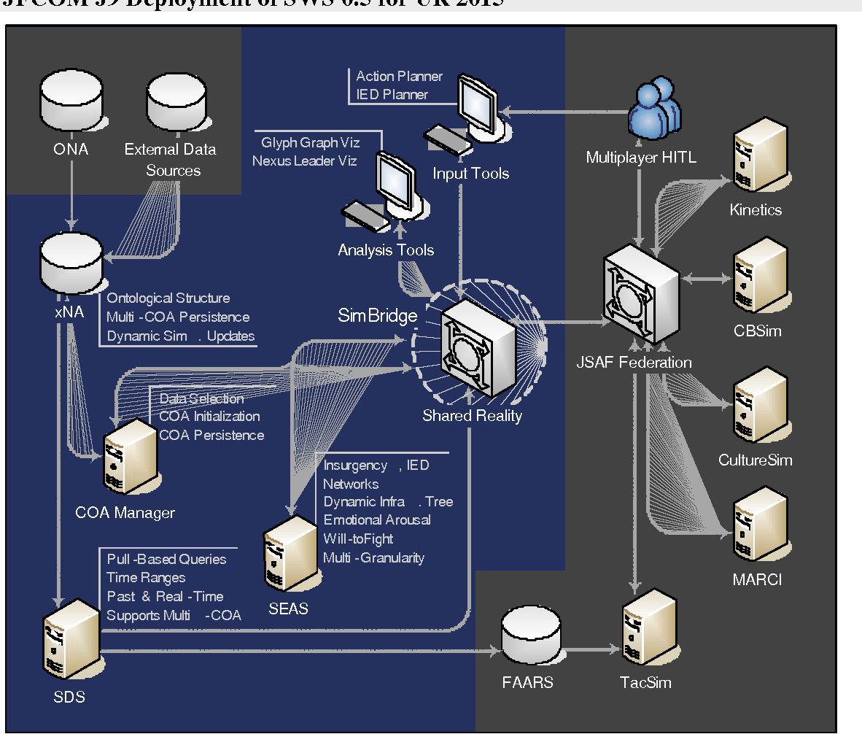
4. DARPA Ai Sentient World Simulation Software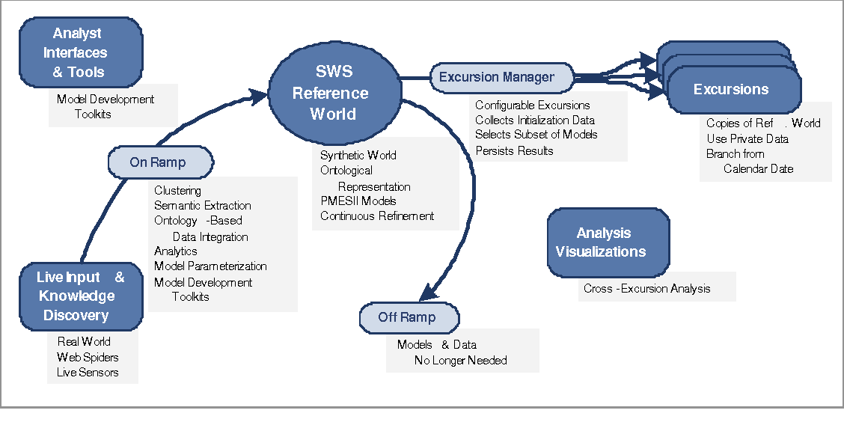
5. Ai Sentient World Simulation Simulated Structured Data Methodology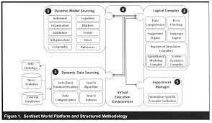
6. LUCIFERASE Quantum Dot Microneedle Vaccination Delivery System 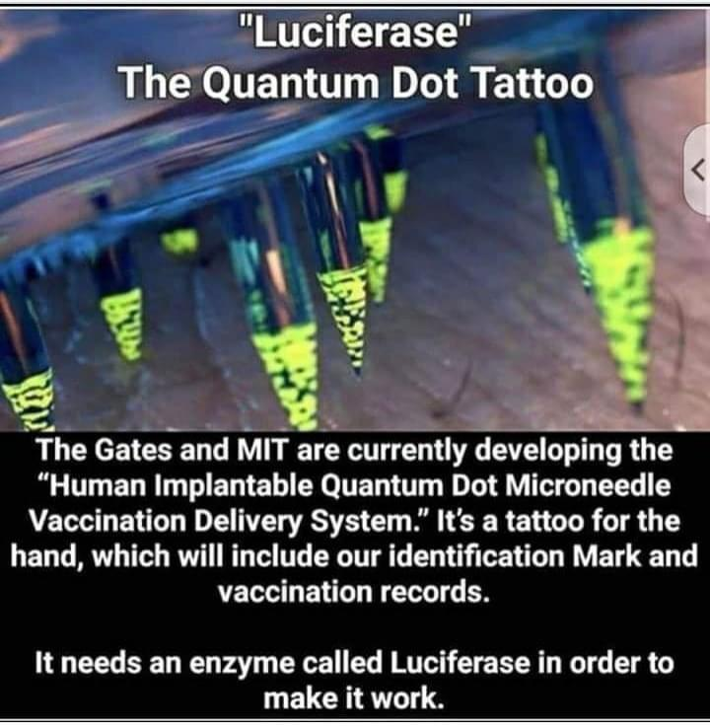
7. How the Quantum Dot Microneedle Tattoo Functions to Deliver a Vaccine 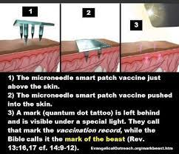
8. COVID-19 SMART Health Card Digital Covid-19 Vaccination QR Code Record
9. Graphene Oxide Silver Nanoparticles: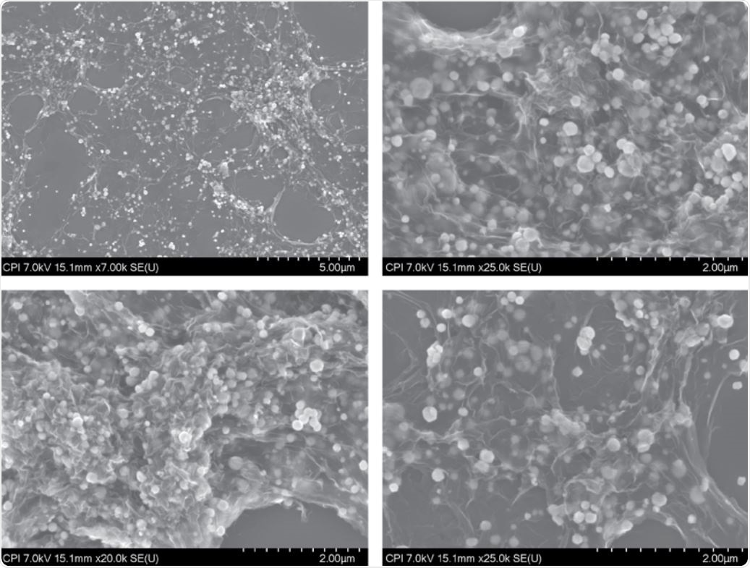
10. “Theragripper” nanotechnology – John Hopkins University

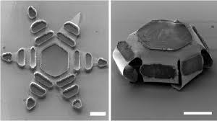

1. Picture of theoretical “angular” structure found in vaccine
2. Theoretical “nanotech” octopus found in vaccine